|  |
| --- |
|  |
| Month Newsletter |
|  |

[Organization]

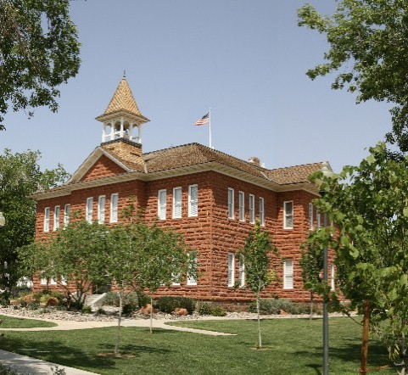

# Upcoming Events

## [Date]

[Event Name]

## [Date]

[Event Name]

## [Date]

[Event Name]

|  |
| --- |
|  |
| Important Announcement [To replace a photo with your own, just right-click it and then choose Change Picture.] |

[Street Address, City, ST ZIP Code]

[Website] T: [Telephone]

|  |
| --- |
|  |
| Dear Reader,  We’ve added a few tips (like this one) to help you get started.  When you click any tip text, the whole tip is highlighted. Just start typing to replace it with your own.  This space is ideal for an intro letter to your readers. As you type, the shaded area will grow with your text.  Warm regards,  Your Friends in Word |
|  |

## Make It Your Own

It takes just a couple of clicks to give a template like this one a whole new look.

On the Design tab of the ribbon, check out the Themes, Colors, and Fonts galleries to preview different looks from a variety of choices. Then just click to apply the one you like.

## Show Off Your Style

You make your fabulous style look easy. So do we.

We’ve created styles that let you match the formatting you see in this template in no time. On the Home tab of the ribbon, check out the Styles gallery to apply any text style used in this newsletter.

# More Important News



|  |
| --- |
|  |
| In the Community[Event Name] [You can add a description and key information about event here.] [Event Name] [You can add a description and key information about event here.] |

## Paint a Picture

If you add pictures to other parts of your newsletter and want to match the cool, two-part border on the photo you see at the top of each page, just paint it!

Format Painter, on the Home tab of the ribbon, works for graphics just like it does for text. All you do is select a photo that contains the formatting you want, click Format Painter, then click the photo where you want to apply that format. Wasn’t that fun?

## Tables Aren’t Just For Numbers

The shaded and bordered areas of this template are created using tables. In fact, when you add a table in this template, you’ll get that formatting automatically.

On the Insert tab, click Table and you’re on your way!

To make it even easier, after you click Table, choose Quick Tables and you’ll see a sample table that’s been formatted to match this template exactly.

## A Quick Sidebar…

If you add another page, you can also add a new sidebar.

Just click in the first paragraph on the new page. Then, on the Insert tab of the ribbon, click Text Box to choose either of the sidebar layouts you see in this template.